Is there Significant SEC Bias in NCAA Football Rankings?
Peter Rosston

It seems like pretty much every single Monday when the new College Football Rankings come out, the chat boards are filled with self-proclaimed critics calling out which teams they feel are overrated or underrated, and where the AP or committee messed up. When the SEC started with 8 ranked teams for the second consecutive season, many people were grumbling about an “SEC Bias.”

To properly determine if there is such a thing, the first thing to do is to define what is meant by “bias.” In this case, bias shown towards teams in the Southeastern Conference would manifest itself in the form of ranking teams from the SEC too high with no solid reasoning. Therefore, I started by looking at the preseason rankings. Of course, preseason rankings are dependent on performance in the previous season. If a team finishes one season ranked, unless they lose key players or a lot of starters, they can reasonably expect to end up ranked around where they finish the previous season. So I went back and looked at preseason rankings compared to final rankings, and in every single season since 2007, the SEC has had more teams ranked at the beginning of the season than at the end of the season, suggesting that voters continue to think SEC teams are better than they end up turning out. What’s more is that since 2007, in every season but 2012, the SEC has had more teams ranked in the preseason poll than they did in the final poll of the previous season.

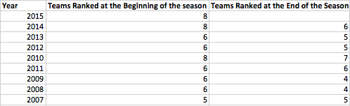

There really is no definite way of determining whether voters and pollsters are biased towards SEC teams. Results against other power five conferences tell us that the SEC has been the most dominant conference in recent history, but even the best conference can still be overrated. What I decided would be the best method to attack the question of bias was to look at all bowl games involving an SEC team and another team, where at least one of the teams was ranked. I then recorded the AP ranking of each team along with the final score of the game.

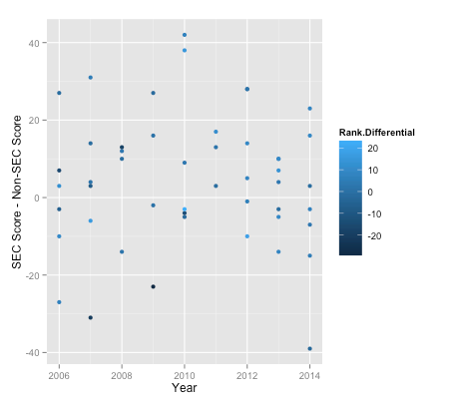

The graph above shows the score differential on the Y-axis of all the bowl games for every year, which is given on the X-axis. To get the score differential, I subtracted the SEC score from the non-SEC score, so any point above 0 on the Y-axis is a win for the SEC team, and any point on below 0 is a loss. Similarly, for rank differential, a positive value means the SEC team was more highly ranked while a negative value means they were the lower ranked team. The resulting graph is unimodal with a peak right on the year 2010. The year actually corresponds to the year the season started, not the year the BCS National Championship game was played. Interestingly enough, 2010 also falls smack in the middle of an eight-year stretch where the SEC had at least one of the two teams in the championship game, including seven of the winners.

Now anyone would be silly to try and argue with the statement that over the past ten years, the SEC has been the best conference in college football. But even the best conferences can still be overrated. Before the eight year run of dominance the SEC had, the previous seven seasons before that (1999-2005), they only had a team in the title game once. Now looking back at the graph, the overall shape can be deceiving. Although there is a definite peak in 2010, in pretty much every single season, between two and four ranked SEC team won bowl games and between two and four ranked SEC teams lost bowl games. All that changed was the margin of victory. In essence, SEC teams were performing just as well for all eight years. What does change, however, is the rank differential.

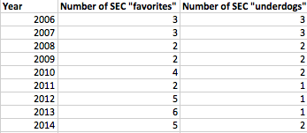

As you can see from the table above, after the 2010 season, the ratio of SEC “favorites” or the higher ranked team out of the two to SEC “underdogs” or the lower ranked team out of the two increased drastically. What this means is that by no increased level of performance, AP pollsters started to inflate the rankings of SEC teams.

So, the evidence does seem to suggest that SEC teams get the benefit of the doubt when it comes to rankings, and that voters are slightly biased towards what has been the most dominant conference in college football over the past decade. It’s hard to blame them. Ultimately, in a sport where the number of intraconference games greatly outweighs the number of interconference games each season, it is very hard to truly judge just how good a team is.

